Initial Design Idea (Visual Style & Mood)
Our initial idea for the visual design of the website is to create a soft, calm and eco-inspired look that reflects sustainability and natural living.
The website should feel light, warm and welcoming, avoiding heavy, sharp or “chemical” design elements. The overall mood is natural and gentle, inspired by organic materials and nature.
Colour palette: Soft greens, muted beige, light yellow tones and warm neutrals inspired by plants, straw, wood and natural fibres.
Design feeling: Clean, minimal and airy layout with plenty of white space to avoid visual overload.
Typography: Simple, readable fonts with a friendly and calm appearance.
Images & icons: Natural, eco-themed images and illustrations (plants, leaves, flowers, kitchen and home items), with soft lines and minimal contrast.

User Experience
The design should communicate trust, sustainability and a connection to nature.
Design Inspiration
This design concept is inspired by eco-friendly online stores and represents our initial vision, which may evolve as the project develops.
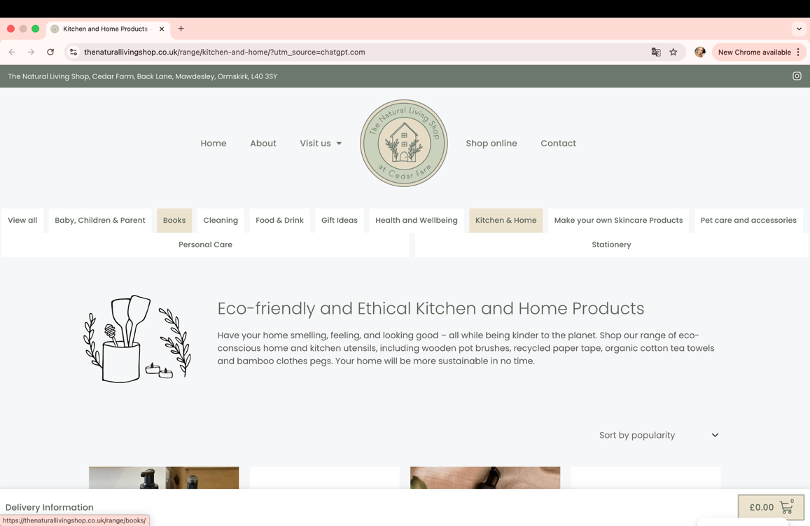

Colour Pallete

Primary colours
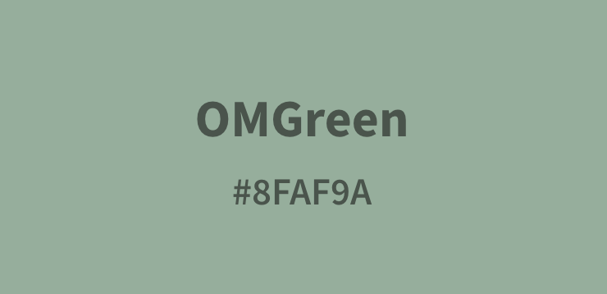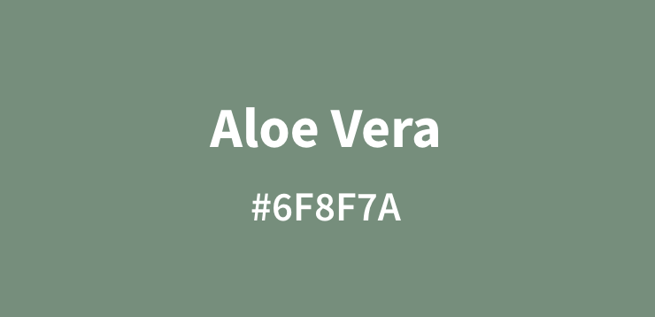

Neutral / background
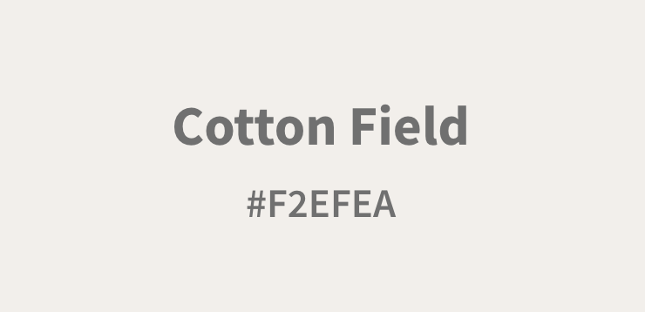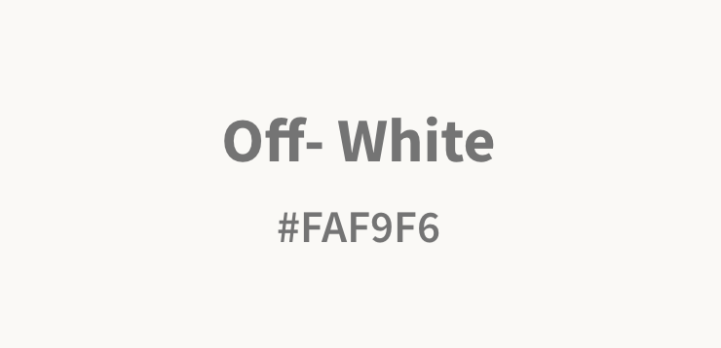

Accent colours
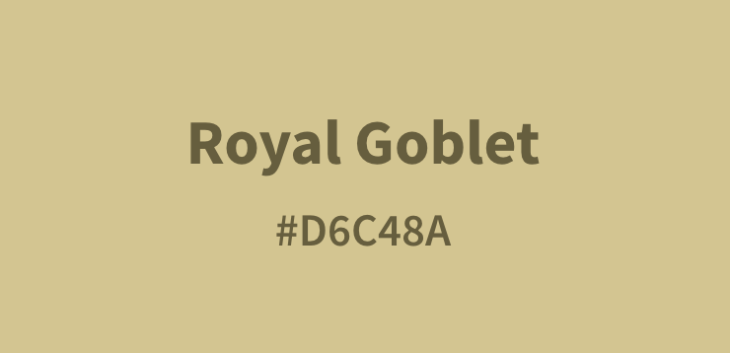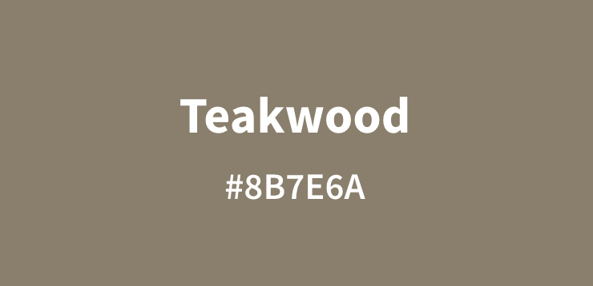

Text
